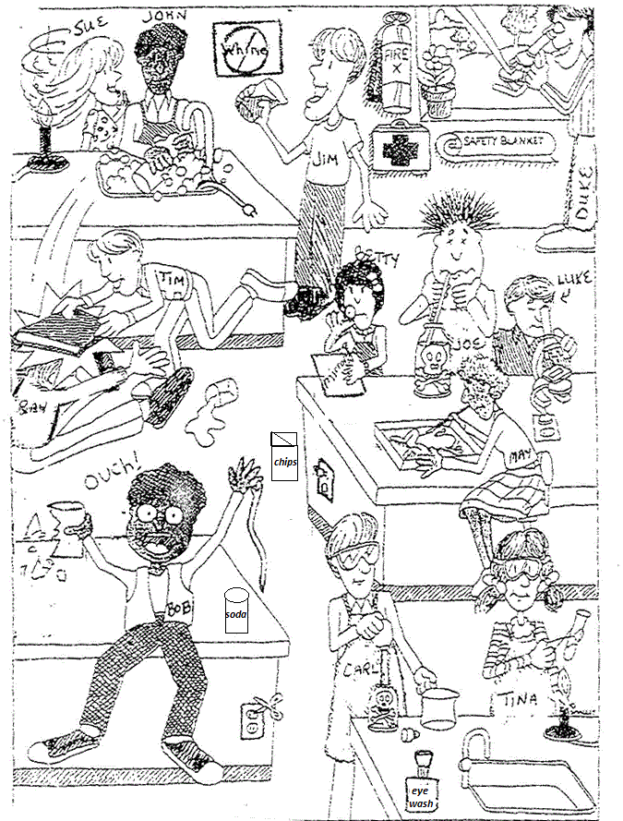

One of the lab safety guidelines is to know where to find and use the first aid, and safety. Where is the first aid in this classroom?
- On the floor
- By the door
- Nest to the window
- Under the desk
Which student is wearing the appropriate equipment for the lab?
- Bob
- Tina
- May
- Tim
One of our safety rules states you should take special care ion handling or using any equipment, materials, plants, or animals. Who is violating this safety rule?
- Tina
- May
- Sue
- Bob

